**EXERCISE 05**

**Source Code**

sbit LCD_RS at RB0_bit;

sbit LCD_EN at RB1_bit;

sbit LCD_D4 at RB4_bit;

sbit LCD_D5 at RB5_bit;

sbit LCD_D6 at RB6_bit;

sbit LCD_D7 at RB7_bit;

sbit LCD_RS_Direction at TRISB0_bit;

sbit LCD_EN_Direction at TRISB1_bit;

sbit LCD_D4_Direction at TRISB4_bit;

sbit LCD_D5_Direction at TRISB5_bit;

sbit LCD_D6_Direction at TRISB6_bit;

sbit LCD_D7_Direction at TRISB7_bit;

char txt1[] = "********";

char i;

int pos1;

void Move_Delay() {

Delay_ms(100);

}

void main(){

CCP1CON = 0x00;

T1CON = 0x00;

VRCON = 0x00;

INTCON = 0x00;

CMCON = 0x07;

Lcd_Init();

Lcd_Cmd(_LCD_CLEAR);

Lcd_Cmd(_LCD_CURSOR_OFF);

Delay_ms(10);

Lcd_Out(1,1,txt1);

Move_Delay();

while(1) {

pos1=5;

// Move outward

for(i = 1; i < 17; i++) {

Lcd_Cmd(_LCD_CLEAR);

Lcd_Out(1,i,txt1);

Move_Delay();

}

// Move inward

for(i = 16; i > 0; i--) {

Lcd_Cmd(_LCD_CLEAR);

Lcd_Out(2,i,txt1);

Move_Delay();

}

for(i = 0; i < 1; i++) {

Lcd_Cmd(_LCD_CLEAR);

Lcd_Out(1,i,txt1);

Move_Delay();

}

}

}

**Circuit**

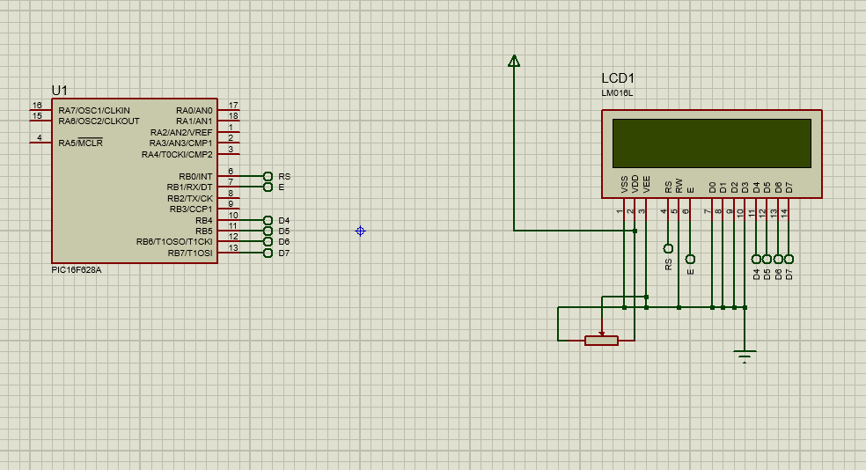

**Observations**

